System Admin - Creating new Shift Types/Work Schedules

These steps are followed by HR Systems when creating new shift types

Introduction
A shift type determines the hours an employee is contracted to work. Departmental HR Administrators assign the appropriate shift types to appointments via People Management > Work Schedule, but can only assign shift types that have been created by HR Systems.

Shift Types and Daily Work Patterns
Shift Types are formed by assigning a work pattern to each day of the week. A work pattern is the number of hours worked in a day, the start and end times are irrelevant, so an employee working 5 hours on a Monday starting at 08:00AM would require the same work pattern as an employee working 5 hours on a Monday starting at 11:00AM.
Work patterns are broken into 3 minute intervals (the lowest number that can be accurately decimalised) The largest work pattern available is a 13 hour day.
On days when employees are not required to work the ‘REST’ work pattern is used.

Rotating/flexible shift patterns
Most employees follow the same pattern each week. If an employee varies between different patterns each week, including see part B
If an employee has a flexi-time arrangement, where there is no predefined pattern, they should be assigned one of the standard shifts based on their average daily hours. For example, if someone works 25 hours across 5 days, they should be assigned a shift type with a 5 hour work pattern on each day, Monday-Friday.

Generating a shift type code
Each shift type has a unique code and a short name (description). The codes for weekly shift patterns are generated using the Shift Type Code Generator, with each code represents a unique combination of daily work patterns. This prevents multiple shift types being created with the same pattern. Codes for Rotating shift types are linked to the employee appointments.

Part A - Weekly shift patterns

Departmental HR should request a new shift type via OSM and provide a copy of the Shift Code Generator for the shift type required.

- Login to CoreHR Back Office
- Navigate to CoreTime/CoreRoster > System Parameters > Shift Types
- Click on the ‘?’ and search for the shift code to check if it has already been created
- Paste the Shift Code into the ‘Type’ Field

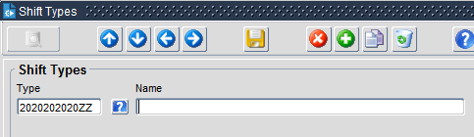

- Enter a description of the shift into the name field. The description will help the HR Administrators to assign the correct shift, but due to the limited character count (40) it is not always possible to fully describe the pattern.
PT 10Hr Week Mon-Fri 2Hrs

Begin with either FT* or PT to indicate if the shift is part-time or full-time.

Enter the number of weekly hours followed by ‘Hr Week’

Describe the pattern. as clearly as possible using the remaining characters
PT 26Hr Week Mon7.5 Tu3.5 Wed6 Thu9 2Hrs

Example 1:
Example 2:

* the most common full-time shift patterns (e.g. working 7.5 hours a day Monday-Friday) have a numerical prefix so that they appear at the top of the list.
Note: any TUPE full time shift patterns should be set up with the TUPE prefix in the description:
TUPE FT_35Hr Week Mon-Fri_7Hrs

Example 3:

And the code should begin TUPEFT followed by a description of the pattern worked E.g. TUPEFT7MF
- Enter N/A for the Short Name

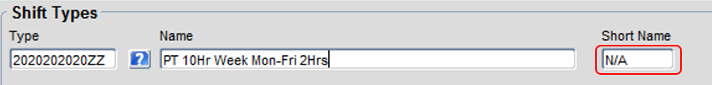

- Tick the ‘Cycle Shift’ checkbox. 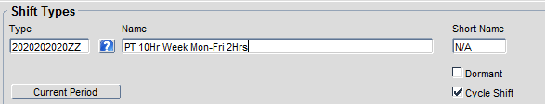

- Within the Shift Patterns section, enter the ‘Seq No.’ as 1

Then use the ‘?’ to select the relevant daily work pattern for each day of the week.

Any days without hours must be set to ‘REST’

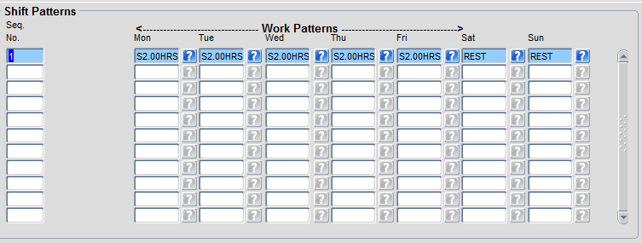

Work Patterns follow the format S#.##HRS.
You can find the correct work pattern quickly by entering the hours
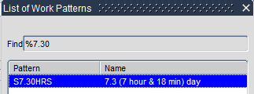

- Finally, Click on the yellow disk in the title menu to save the shift.

Part B - Rotating shifts (including term-time only)

- Login to CoreHR Back Office
- Navigate to CoreTime/CoreRoster > System Parameters > Shift Types
- Click on the ‘?’ and search for the shift code to check if it has already been created
- Enter the Shift Code into the ‘Type’ Field

Rotating shift type codes follow the format: RT<APP. ID><VERSION LETTER>

For example; RT12345-1A

Term-Time Only shift type codes follow the format: TT<APP. ID><VERSION LETTER>

For example; TT15432-1B

- Enter a description of the shift into the name field. Including the Appointment ID and Personnel No. will help HR assign the correct shift

Rotating shifts should follow the format:
R##.##HRS <APP.ID> <PERSONNEL No.> <VERSION LETTER>
If the number of hours differs each week, you can insert the word average.
R##.##HRS Average <APP.ID> <PERSONNEL No.> <VERSION LETTER>

For example; R27HRS 12345-1 1234567A
R27HRS Average 12345-1 1234567A

Term-Time only shifts should follow the format:
TT##.##HRS <APP.ID> <PERSONNEL No.> <VERSION LETTER>
If the number of hours differs each week, you can insert the word average.
TT##.##HRS Average <APP.ID> <PERSONNEL No.> <VERSION LETTER>

- Enter N/A for the Short Name

- Tick the ‘Cycle Shift’ checkbox.

- Within the Shift Patterns section, enter the ‘Seq No.’ 1 into the first row

Then use the ‘?’ to select the relevant daily work pattern for each day of the week.

Any days without hours must be set to ‘REST’

Now repeat for the other weeks in the rotating pattern, increasing the sequence number with each row.
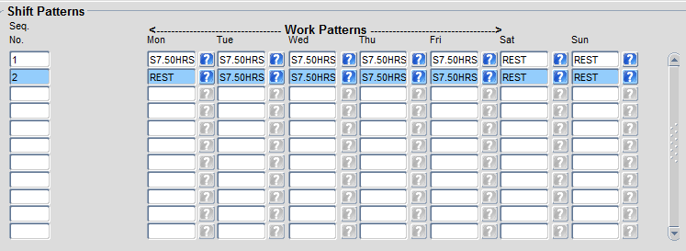

- Finally, Click on the yellow disk in the title menu to save the shift.

Reporting
Note that you can run the “Core Time Shift Type Reference Data List.sql” held in the Functional Analyst SQL Library to return a list of all existing shift types set up in the system. This can be used to check any data created as part of testing.

